* Lesson:-1 (Indian Historical Person)

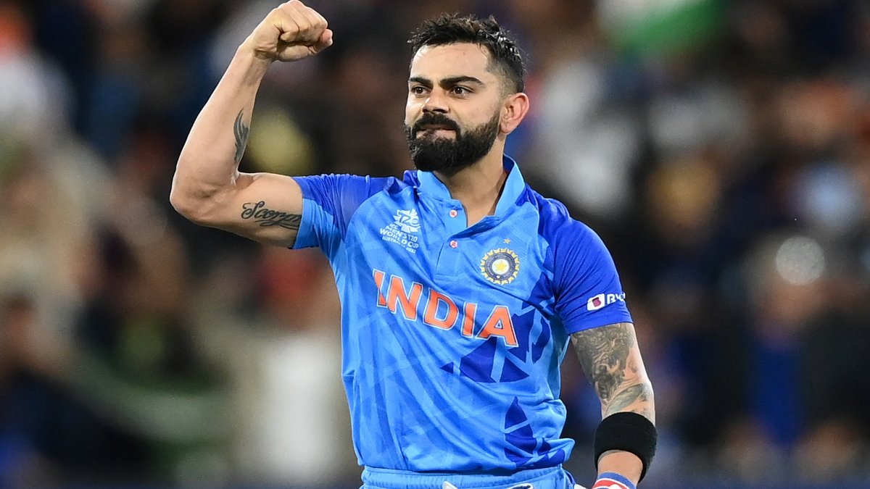

(Virat Kohli) :-is an Indian international cricket player. He is a middle order batsman, who can also open the batting. He can also bowl right arm medium pace. He got his initial cricket training in West Delhi Cricket Academy, since its inception in 1998. Virat Kohli has been linked to various high-profile women over time. He has dated Sarah Jane Dias, an Indian Model, and VJ, Sanjana, another actress for a short while. For a while he’s dated Tamanna Bhatia, Izabelle Leite, a Brazilian Model and lately he was in a quite a high profile relationship with Bollywood actress Anushka Sharma.

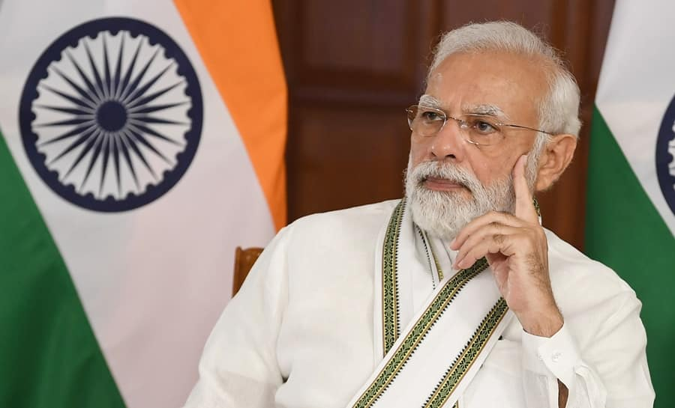

(Narendra Modi):- in full Narendra Damodardas Modi, (born September 17, 1950, Vadnagar, India), Indian politician and government official who rose to become a senior leader of the Bharatiya Janata Party (BJP). In 2014 he led his party to victory in elections to the Lok Sabha (lower chamber of the Indian parliament), after which he was sworn in as prime minister of India. Prior to that he had served (2001–14) as chief minister (head of government) of Gujarat state in western India.

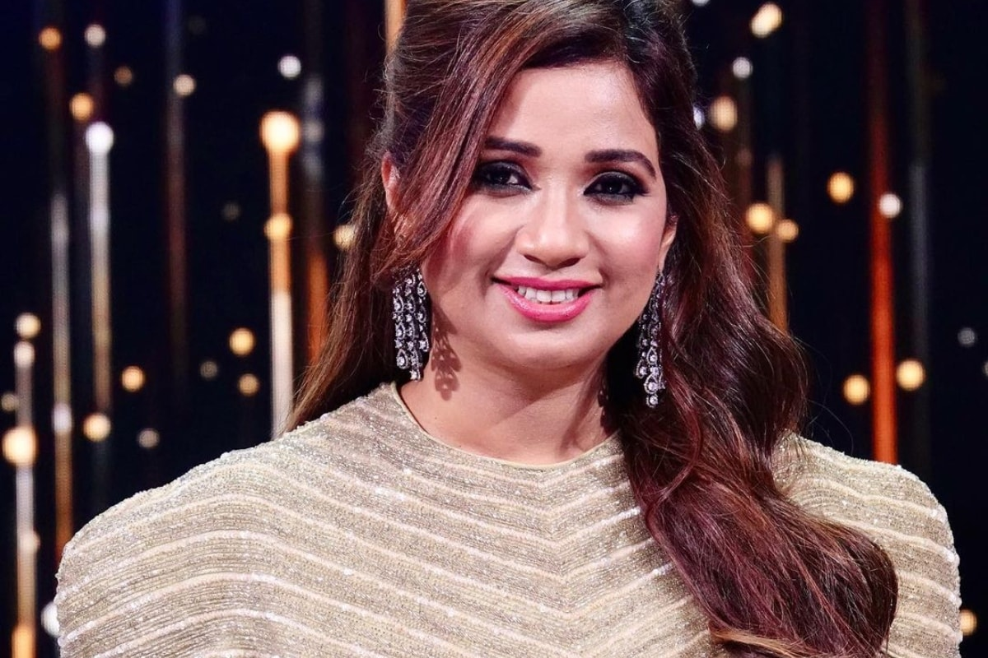

(Shreya Ghoshal) :-(born 12 March 1984)[2] is an Indian playback singer. She has received four National Film Awards, six Filmfare Awards including five for Best Female Playback Singer, nine Filmfare Awards South, three Kerala State Film Awards and two Tamil Nadu State Film Awards. She has recorded songs for film music and albums in various Indian languages and has established herself as a leading playback singer of Indian cinema.